**Exercise**

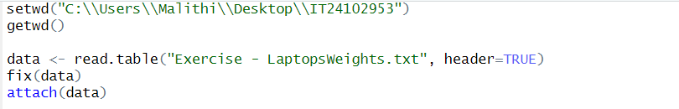

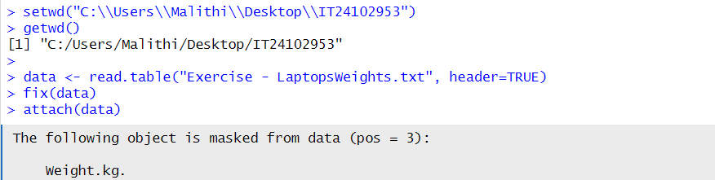

01.

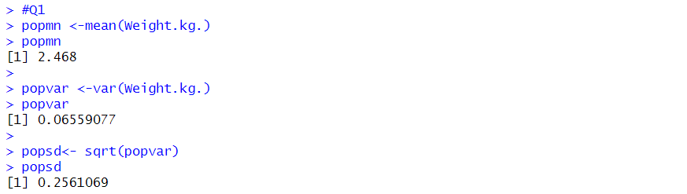

02.

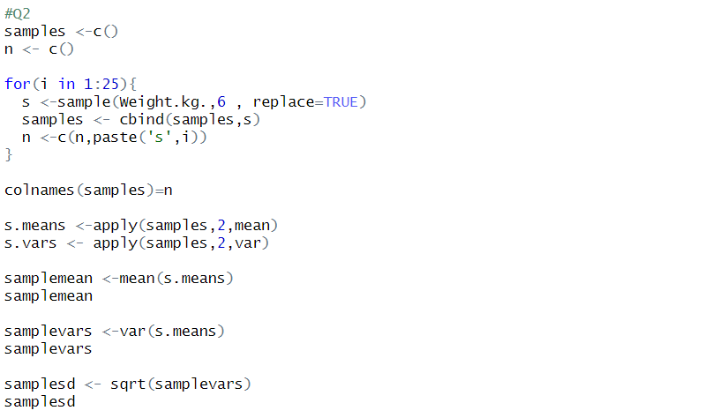

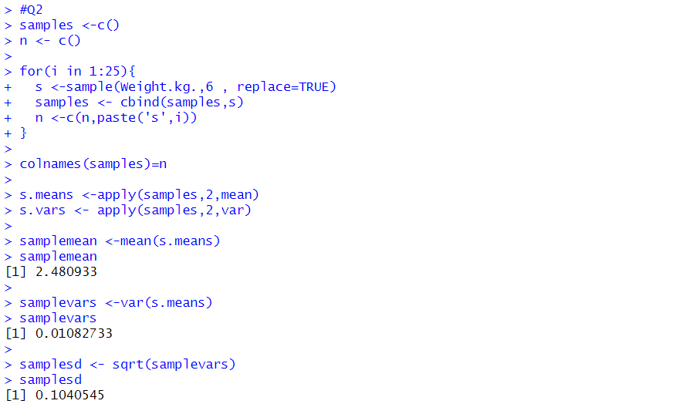

03.

